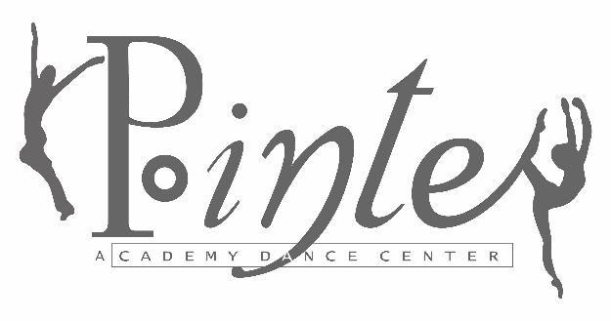
837 E. Auburn – Rochester Hills, MI 48307
Fairy Princess Camp
Calling All Princesses!!!

Who: Pre-Dancers / Level I & II Students (ages 3-8)

When: July 24, 25, 26 (T, W, Th) 9:30-10:45 am

What: Come and have fun with fairy tale magic as we dance to your favorite princess songs. Our camp includes instruction in basic ballet, jazz & creative movement. Princesses will work on their Ballet technique and learn new steps! We will have a craft, snack and story time. The camp will end with a performance for our parents!

Cost: $55 (If you sign up by May 31, pay only $45)
Space is limited and will be filled on a first-come, first-serve basis.

Please drop off registration at the desk or mail to:
Pointe Academy Dance Center
P.O. Box 81904 – Rochester, MI 48308

Name Age

Address

Email Phone

Allergies Level

